Rotary Club of Kathmandu Mid-Town
Breakfast Chatter



29 September 2006 The Weekly Bulletin of Rotary Club of Kathmandu Mid-Town Bc # 13 of 2006-07

District : 3290 Web: www.rotarymidtown.org.np Club Id : 26776

SEPTEMBER IS NEW GENERATIONS MONTH
Interact, Rotaract, Youth Exchange, and RYLA all build upon the goals of personal growth and leadership of youth by youth. In short, these programs build character. They also represent a wonderful source of future Rotarians, already acquainted with the ideals of Rotary International.

Second Club Assembly :
The second Club Assembly of the year was held on Friday, 22 September as per the schedule. On request of President CK, Zone VI AG Dr C Lekha Tuladhar witnessed and conducted the club assembly meeting.
The following Club officers presented review of programs and activities of the respective venues for information and guidelines:
Club Service Director, RR Shrestha
Vocational Service Director, Govinda Chipalu
Community Service Director, Peter Clawson
International Service Director, Saroj Shrestha
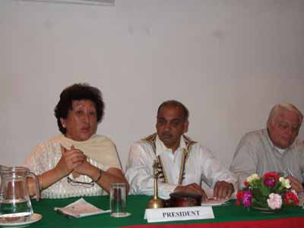
Zone VI AG Dr C Lekha Tuladhar conducting club assembly and providing guidelines to club officers and members. She had to remind members that during Club assembly there should not be any question/answer session between club officer and members. After presentation by the concerned club officer, the AG conducting CA would seek whatever clarifications needed and then provide guidelines.

Weekly Meetings and Programs
Date | Program/Speaker | Program/Topics of Presentation
29 September 2006 | No meeting | Dashain holiday
6 October 2006 | Rtn Badan L Nyachhyon | Urban concern: waste free community
13 October 2006 | ?? | ??
20 October 2006 | Dr Isabella C B'nana Khadka | Past Reminiscences and Present Musings

Friday, 29 September :
No meeting ! Enjoy Dashain !!

Festive Greetings :
On the auspicious occasion of
HAPPY VIJAYA DASHAMI 2063
May Almighty Goddess Durga Bhawani
bestow Her blessings to all
for good understanding with all, and for peace and happiness.


Kite Flying :
To mark the start of Dashain there was a kite flying program on Saturday, 23 Sept 2006 for fun as well as for informal fellowship. It was a joint program with Rotaracts of Kathmandu Mid-Town.
The venue was at the roof-terrace of Kathmandu Mall shopping complex building, Sundhara, Tundikhel.
Courtsey: PP Jyotsna Shrestha
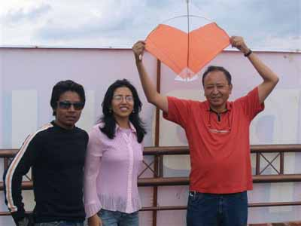
PP Arun M Sherchan with two Rotaracts helping for kite lift-up.
Guess, who is at the other end ?
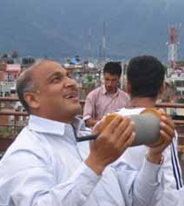

Everything we do, positive and negative, reflects on all Rotarians everywhere. And so let everything we do be positive, and let it be fun.
RI President William B. Boyd

29 September 2006 The Weekly Bulletin of Rotary Club of Kathmandu Mid-Town Bc # 13 of 2006-07

Editor: RR Shrestha, Club Service Director email: rryes@wlink.com.np

